**PROJECT REPORT  
Student Database Management System**



**Project Members:**Sakshi Tiwari (20103216)  
Khushi Rana (20103222)  
Yash Mangla (20103231)  
Yatin Garg (20103229)

**About Us**

The **Student Database Management System** has been developed to override the problems prevailing in the manual system. With the help of Student management system it is easy to keep record of each and every student. It allows easy access for student for accessing his/her record at any time and from anywhere. With the help of this virtual medium it is easy to manage and keep record of the performance of student.

The updates in the database are made as when required to keep the consistency and integrity of data in place.

It manages all the information about profiles,student,fees,etc.The purpose of the project is to build an application program to reduce the manual work for creating profiles,courses,student logins.It tracks all the details about the logins,exams,fees.It deals with monitoring the information and transactions of exams.Management of the information of profiles,editing,adding and updating of records is improved which eventually results in proper resource management of profiles data.Student management system can lead to error free,secure,reliable and fast management of official data.

The aim is to automate its existing manual system by the help of computerized equipments and full-fledged computer software,full filling their requirements,so that their valuable data can be stored for a longer period with easy accessing and manipulation of the same.

**Entity Relationship Diagram  
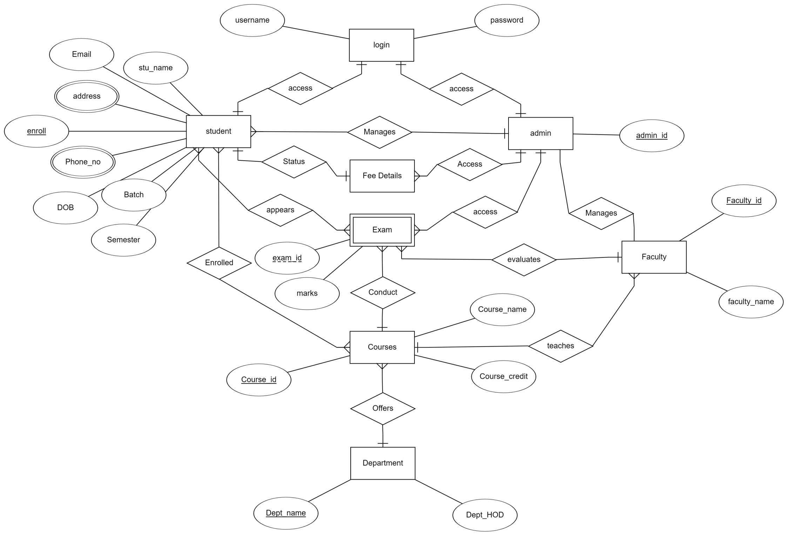**

**Interface Features:**

* It provides an interface for **student and admin LOGIN**

Login page serves the purpose of user authentication.  
Validation checks are made against the predefined criteria.  
🡪 Username must not be NULL value  
🡪 Password must not be NULL value  
Successful login establishes a session for the particular user.

**Admin Interface**

* Admin is privileged to **edit marks** of the students
* Admin has the liberty to **edit fees status** of the students

**Student Interface**

* Student can see his/her **personal information**

Data is fetched from the STUDENT table against the student’s enrollment number.  
Enrollment No.  
Name  
Personal E-mail ID  
Semester  
Batch  
Date of Birth  
Address  
Phone No.

* Shows the **courses** in which student is enrolled in

The table Enrolled defines the relationship between the student and course.

* Student can see his/her performance in previous years in the form of **result**

Computation is based on the marks scored and credits earned.

* The status of the **fees** paid by the Student is visible to him/her

The data about every semester is fetched from the fee details table.**Database Features**

The database is to be designed so as to provide the following features:

* Storing student’s personal and academic details.
* Maintaining record of courses offered by various departments to students.
* Providing access to faculty user to manipulate student’s marks.
* Generating results of students based on their performance in examination according to the criteria specified in course details.
* Presenting student’s details in various views as desired by user.

**List of Tables**:

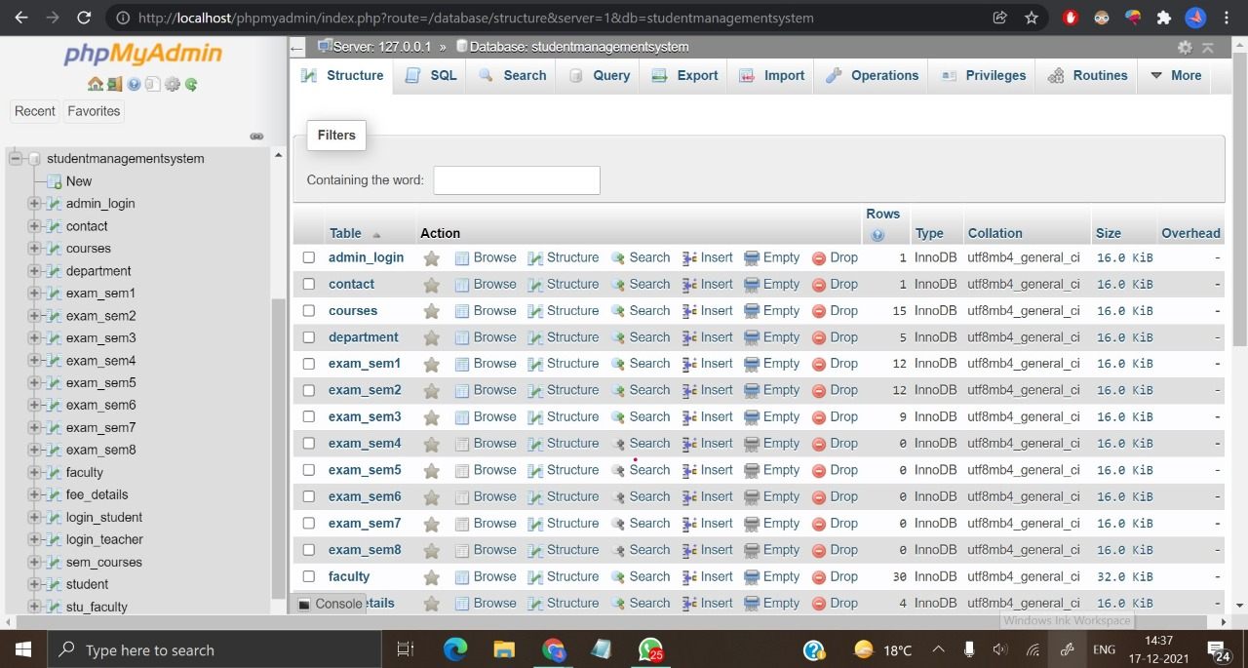

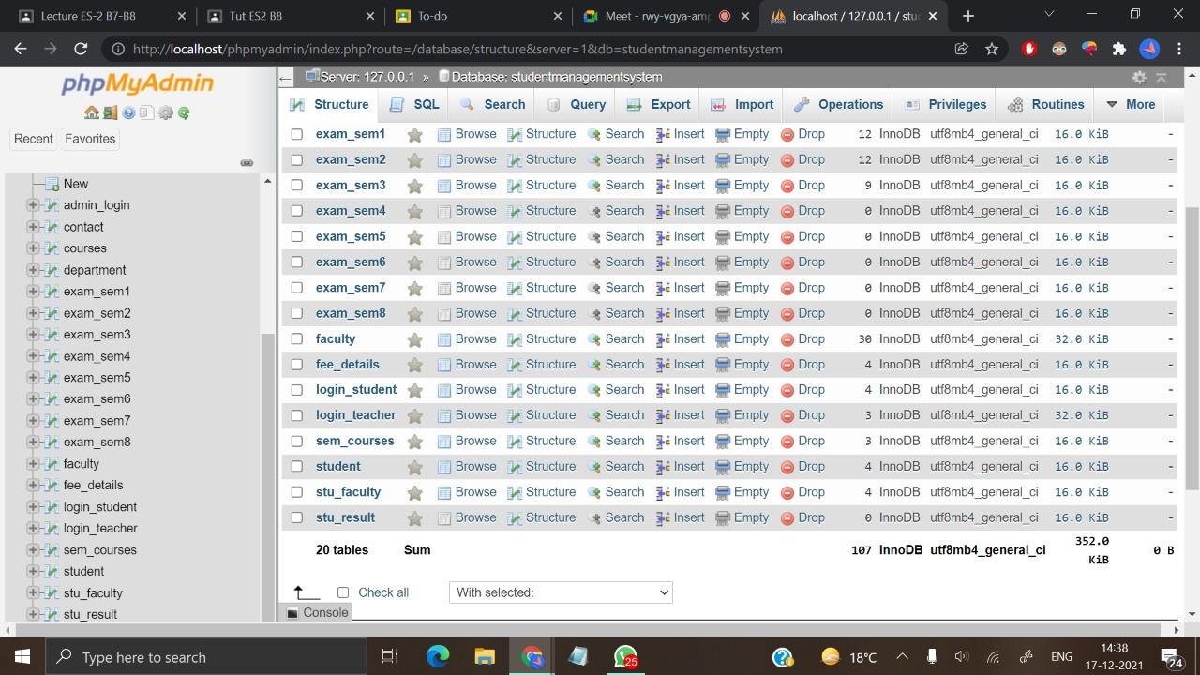

**Languages Used:**

**Front-end:**

* HTML &CSS for making the interface on the client – side

Presentable webpage design.

* JavaScript for making the page more interactive

Validation of user input at login interface.

**Back-end:**

* SQL for keeping records of data and query processing

Definition of relational schema and fetching of required data.

* PHP scripting language for connecting Database with webpage

Establishing session for valid login and providing personal data views to user.

**Screenshots**

LOGIN Page

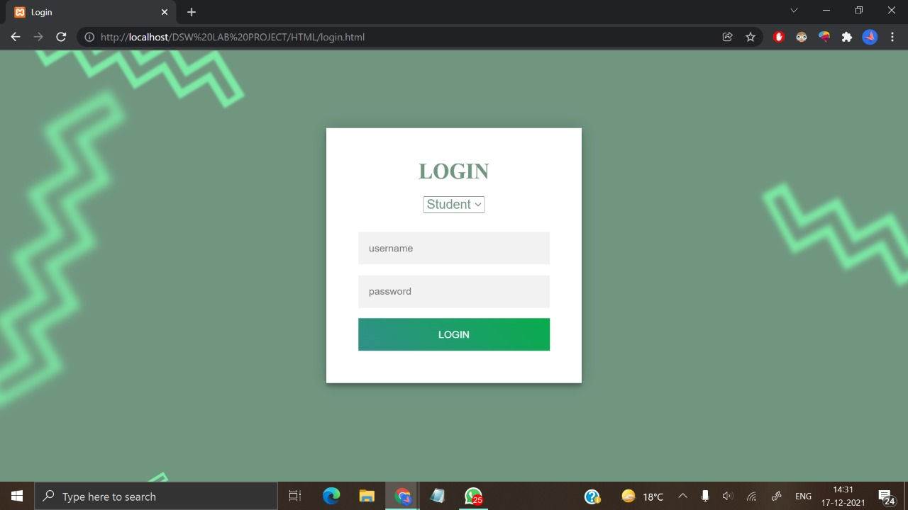

Student Dashboard

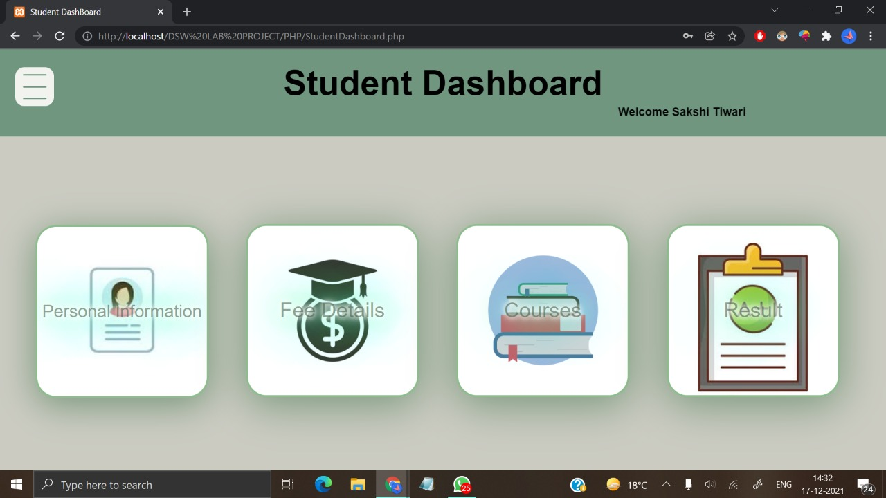

Navigation Links

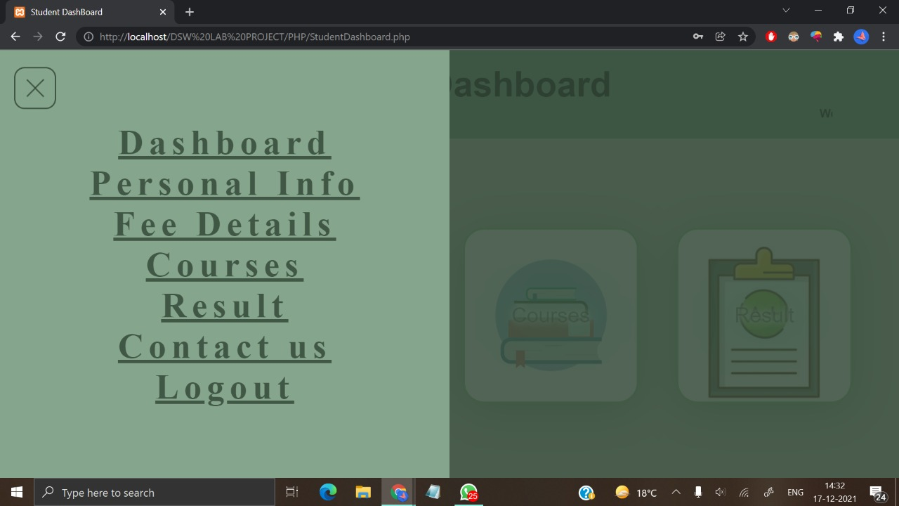

Personal Information View

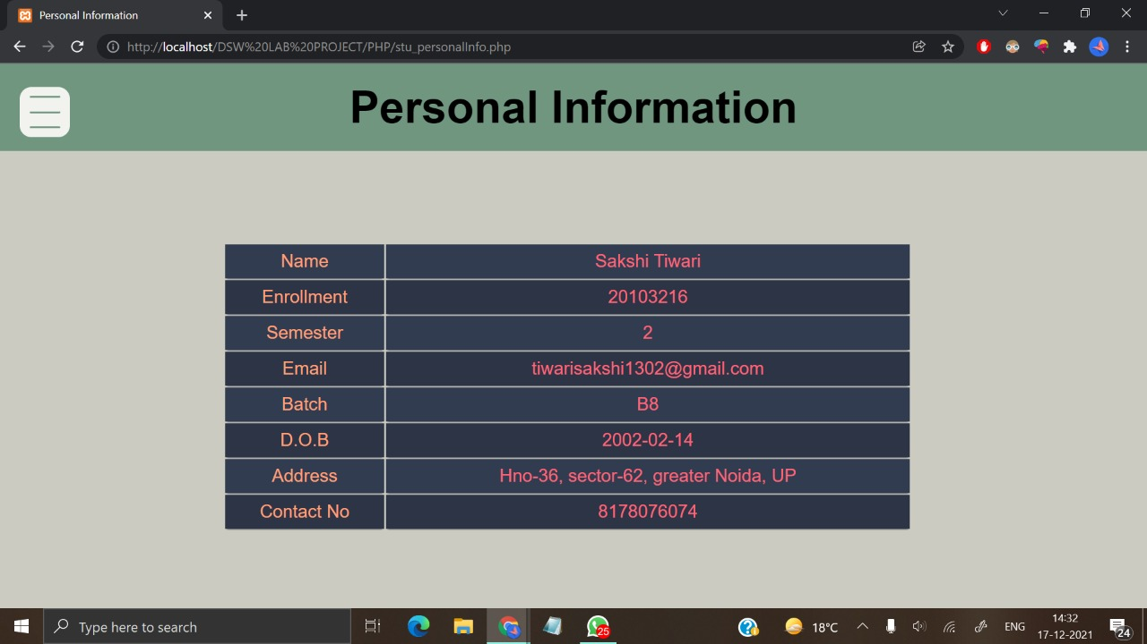

Fee Details View

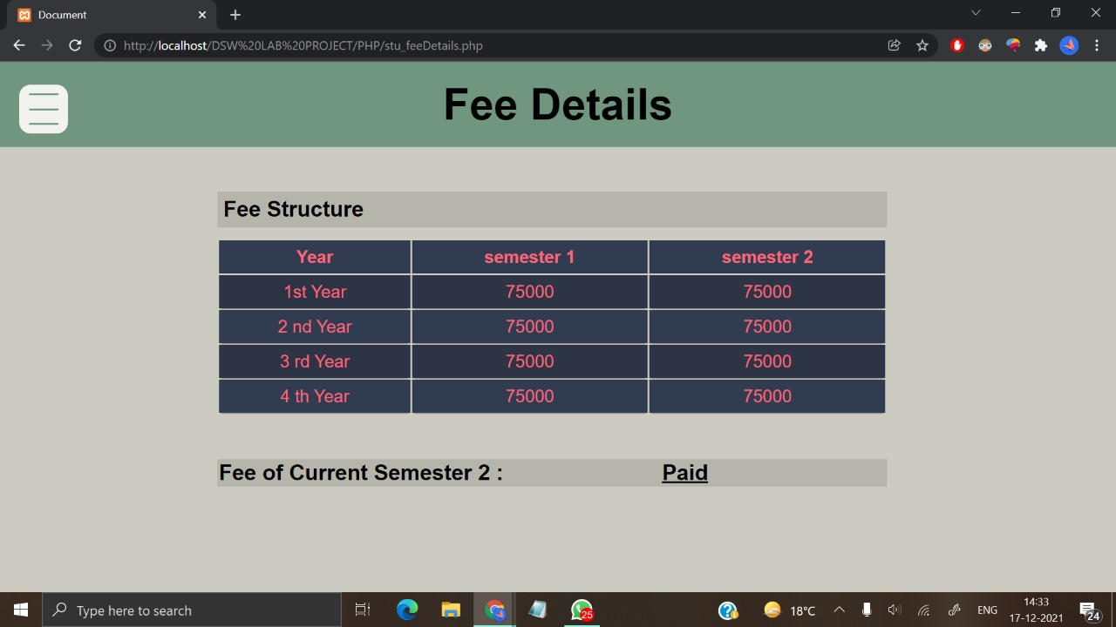

Course Enrolled View

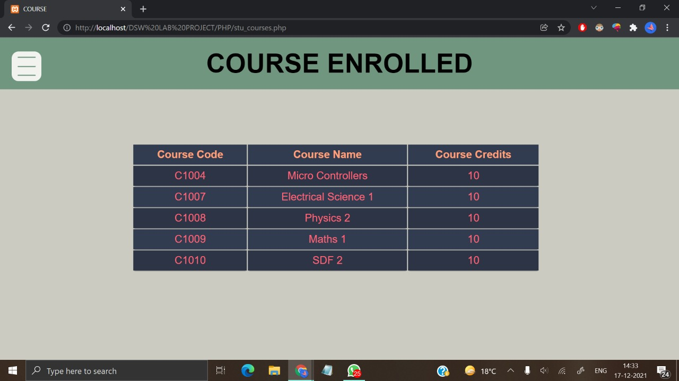

Result Page

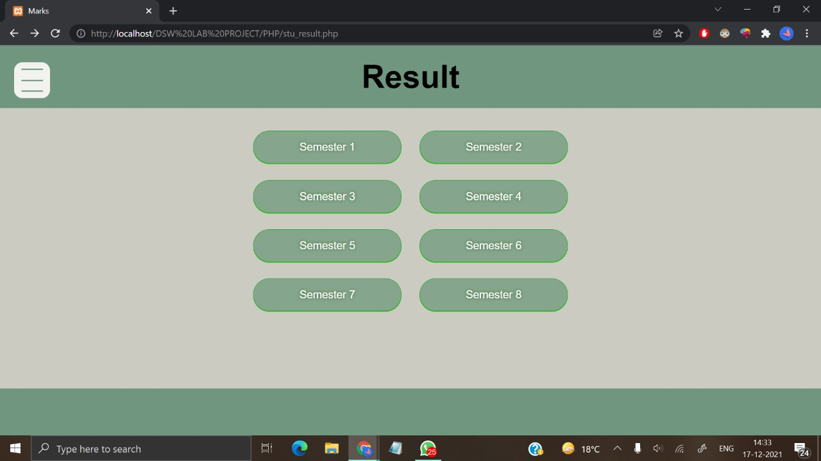

Semester 1 Result View

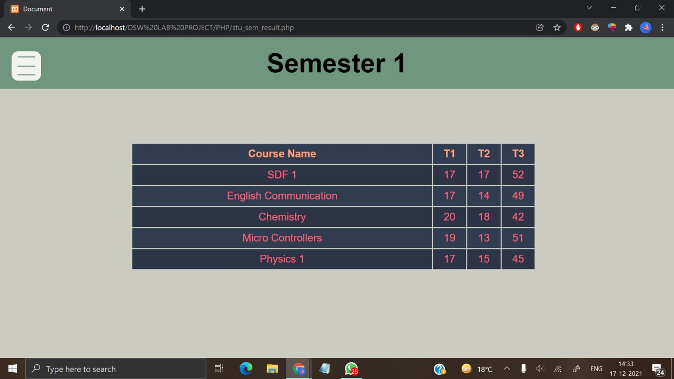

Semester 2 Result View

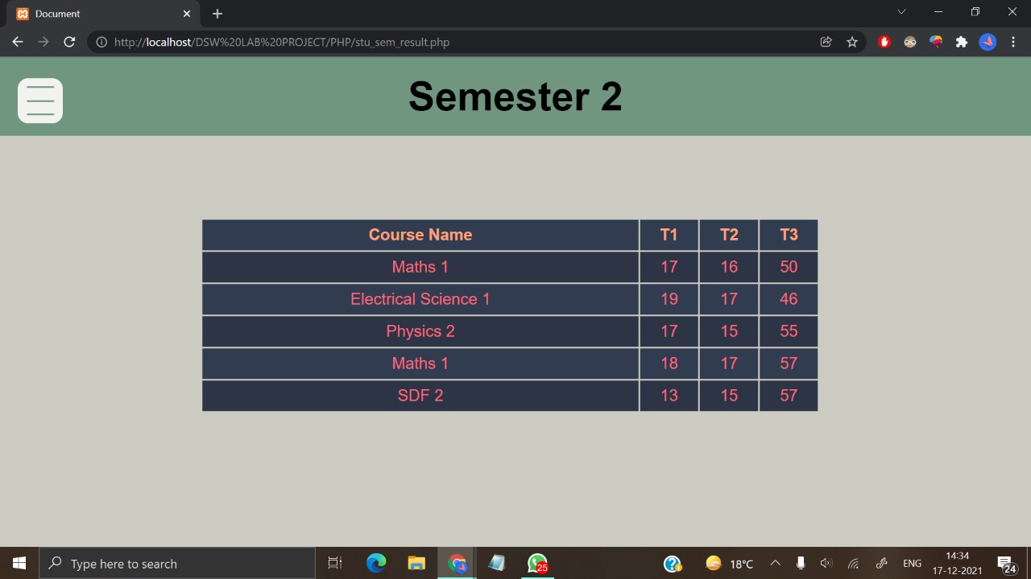

Semester 3 Result View

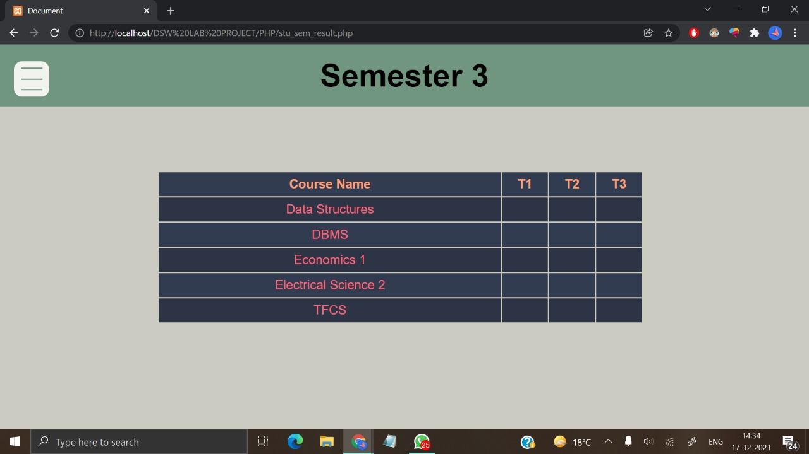

Contact Us Page

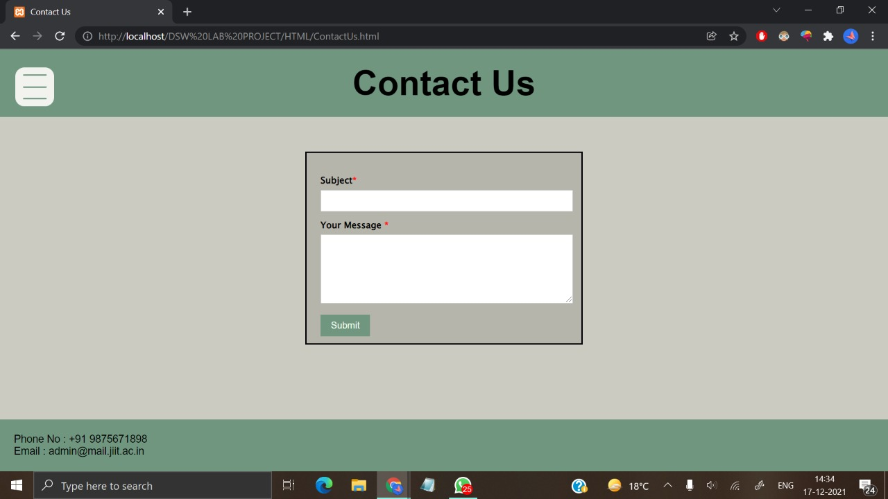

Admin Dashboard

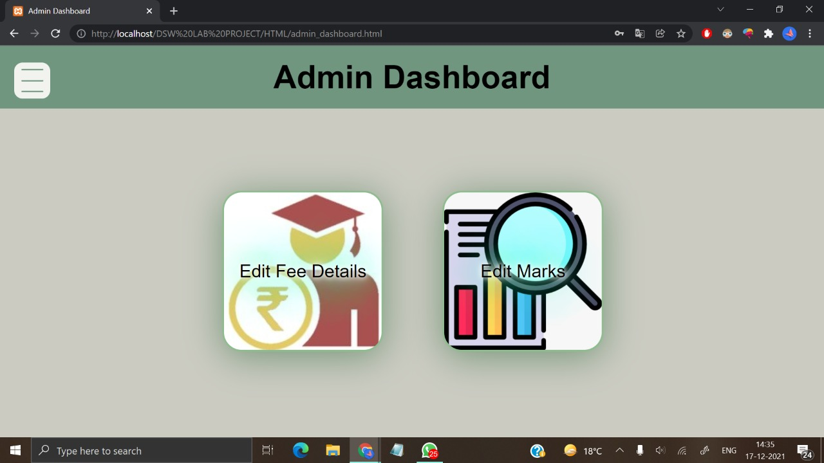

Navigation Links

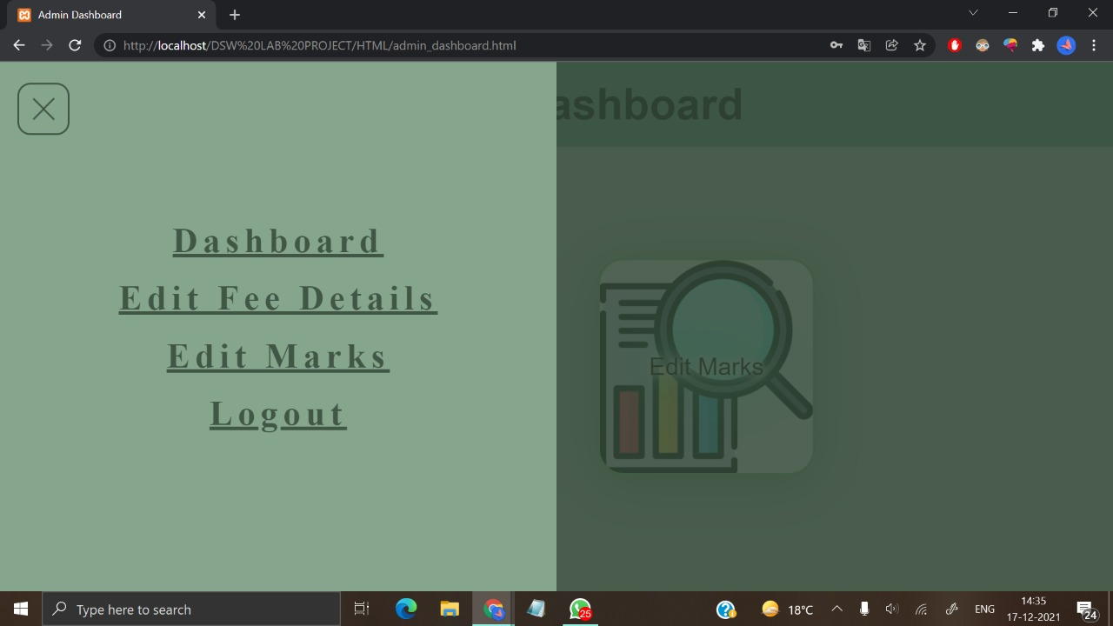

Edit Fee Form

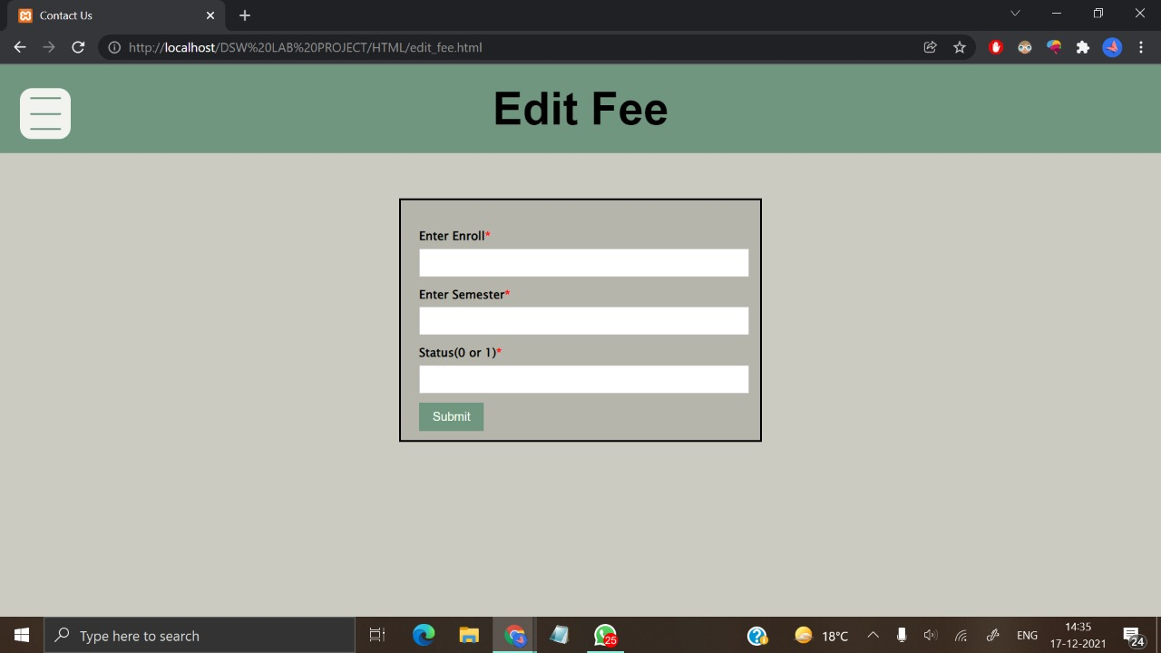

Edit Marks Form

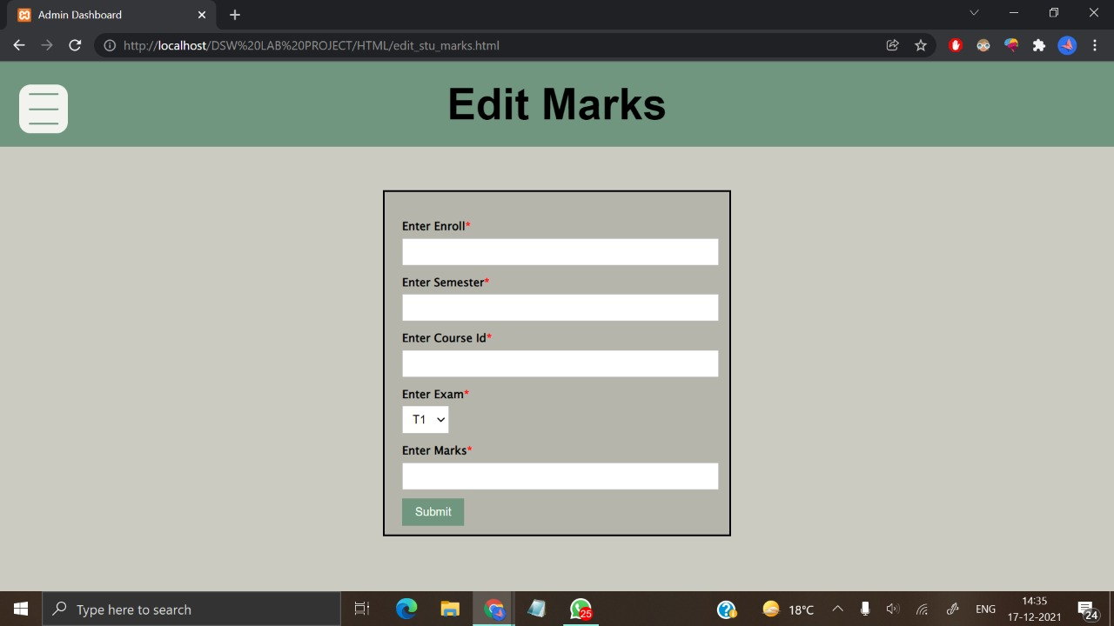

**References**

* <https://www.w3schools.com/>
* <https://stackoverflow.com/>
* <https://www.techiedelight.com/>
* <https://www.geeksforgeeks.org/>
* <https://dev.mysql.com/>